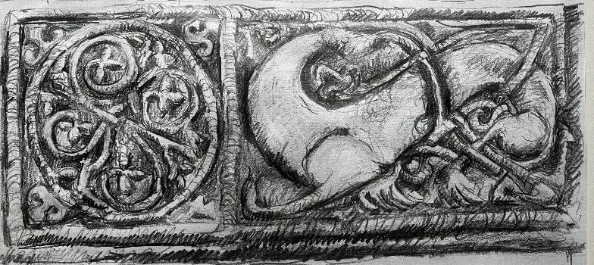

Public generosity helps secure future for much loved ‘Church in the Glen’ for generations to come
Exciting progress made in charity’s purchase of Wamphray Church
A fundraising campaign to retain public ownership of the historic hill church in Wamphray Glen, south of Moffat, has successfully reached its initial £45,000 target.
The trustees of charity Friends of Wamphray Church have expressed their gratitude to the many donors from all over the UK and as far afield as Canada and the US who have supported their campaign, which was launched in January.
Among them was a highly significant, generous donation from a former resident of Wamphray Glen who still feels a deep connection to the church and its sense of place.
The charity also secured £12,500 from Clyde Windfarm and SSE Renewables and a £3,000 grant from the Architectural Heritage Fund specifically to pay for a detailed condition survey.
And more than 50 people have signed up to become annual members of Friends of Wamphray Church.
Friends of Wamphray Church Chair Carol Beattie said: “We are really excited to be able to share the fantastic news that we are progressing with the process of buying the church and therefore securing it for the public, and the community, for generations to come.
“We are incredibly grateful to our many generous donors who have made this possible. The response to the campaign has proved how deeply people care about this little church and its peaceful surrounding landscape and heritage which always touch people’s hearts.”
When the purchase is finalised, Friends of Wamphray Church intends to market the building as an events venue – for weddings, concerts, christenings, talks, walks funerals and other celebratory gatherings - and establish it as a nature and heritage hub, showcasing and celebrating its scenic location and fascinating history.
Carol says: “To move forward with the next chapter for Wamphray Church we will need continued support to help us fund essential, ongoing maintenance and initial developments including the installation of toilets.
“We’re keen to welcome new members who’d be interested in getting involved with the project.”
The 19th century building, which is believed to sit on the site of an early Mediaeval place of worship, holds an important 7th century Anglo/Celtic carved stone cross shaft as a lintel above its front door.
The surrounding landscape is rich in archaeology and the churchyard has several fascinating and significant memorials.
The Church of Scotland closed Wamphray Church on December 28, 2025 and allowed the Friends six months to raise the purchase price of £35,000 before advertising it on the open market.
For more information on becoming a member of Friends of Wamphray Church, or donating to the project, see www.wamphraychurch.com or find Friends of Wamphray Church on Facebook.

ENDS

About:
Wamphray Church: Constructed in 1834 on the site of an earlier mediaeval church, the building holds an important 8th century carved stone cross shaft as a lintel above its front door.
The surrounding landscape is rich in archaeology, with standing stones, the remains of an Iron Age settlement, a Roman camp, a 12th century motte and bailey and Covenanting connections, and the churchyard has several fascinating memorials including to John Rogerson, physician to the Emperor of Russia, and to Rt Rev A H Charteris, Founder of The Woman’s Guild, Moderator of the General Assembly of the Church of Scotland and Chaplain to Queen Victoria.
Friends of Wamphray Church (SC055117): The group formed in November 2025 as a steering group and became a SCIO (Scottish Charitable Incorporated Organisation) in March 2026.

